Capstone Project - The Battle of Neighbourhoods

# Introduction

## For the report, the problem that I’m going to focus on is to get the best neighbourhood for a person who is looking to transfer to Toronto. There are many parameters that one may look up to while deciding which neighbourhood they will want to move into, ranging from the availability of grocery stores or supermarkets in the neighbourhood to their most preferred type of restaurants. In this section, I will be analysing the region of Toronto on which neighbourhood will best suite for a person who is moving from India.

# Business Problem

Many migrants or travellers who come to a new country in the purposes of work often don’t think hard on choosing on which neighbourhood of that city is best suited for them. They mostly apply to stay in a neighbourhood on the basis of first come first serve basis where the individual is happy to select the first offer that comes to their hand. But the after effects of this decision affects the daily livelihood or lifestyle of that individual, if they are hard adapters to the new environment. Taking an example of an Indian who is transferred to Toronto for his work goes to stay in the neighbourhood where local amenities is not suited to his liking, i.e., unavailability of grocery or convenience stores, lack of Indian cuisine restaurants in the locality. They will find it hard to adapting in such a neighbourhood.

# Possible Solution

With the help of the Foursquare Api, I will analyse each neighbourhood in Toronto depending on 3 variables,

* Restaurant
* Grocery Store
* HealthCare facility

Using these variables, we will be able to determine which neighbourhood is best suited for our targeted traveller/migrant. Hence for an Indian traveller we will look into which neighbourhood has the highest number of Indian restaurants or grocery store.

# Data

When we pass in the search query to the foursquare api, we get a json result from it. Using this json result we will see what we can use, so that we are able to find our solution.

{'id': '4b4f6095f964a520eb0327e3',

'name': 'Etobicoke General Hospital',

'location': {'address': '101 Humber College Blvd',

'crossStreet': 'at Hwy 27',

'lat': 43.72986348754193,

'lng': -79.59835052490234,

'labeledLatLngs': [{'label': 'display',

'lat': 43.72986348754193,

'lng': -79.59835052490234}],

'distance': 9761,

'postalCode': 'M9V 1R8',

'cc': 'CA',

'city': 'Toronto',

'state': 'ON',

'country': 'Canada',

'formattedAddress': ['101 Humber College Blvd (at Hwy 27)',

'Toronto ON M9V 1R8',

'Canada']},

'categories': [{'id': '4bf58dd8d48988d196941735',

'name': 'Hospital',

'pluralName': 'Hospitals',

'shortName': 'Hospital',

'icon': {'prefix': 'https://ss3.4sqi.net/img/categories_v2/building/medical_',

'suffix': '.png'},

'primary': True}],

'referralId': 'v-1572186646',

'hasPerk': False}

The highlighted portion of the JSON is the parts which will be used in the primary analysis of the Geospatial data from Foursquare.

The data I’ll be using is the already existing one where we scrapped from the Wikipedia page.

# Approach

Now Starting off with the analysis, first and foremost we’ll look into the number of venues that are related to Indian themed, i.e., Indian Restaurant, Indian Grocery store, etc. To do this we’ll be extracting the geospatial data of each postal area and count the number of such venues in that location. I have set the radius of search to a max of 2 KM, I’m roughly taking this as the average area coverup size of each neighbourhood.

Using the foursquare api, we find the top 10 Neighbourhoods for our first step of our analysis.

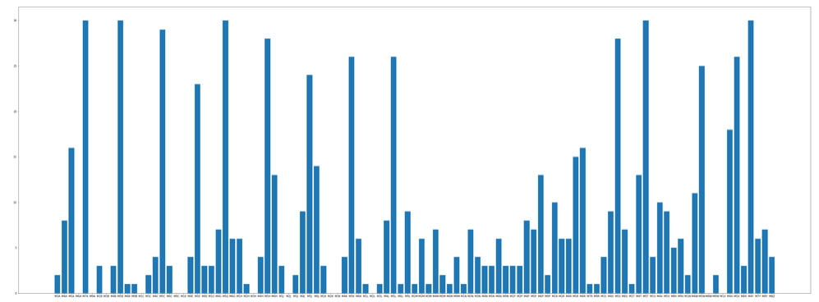

Now we shall filter this complex bar graph by just taking the top 10 neighbourhoods.

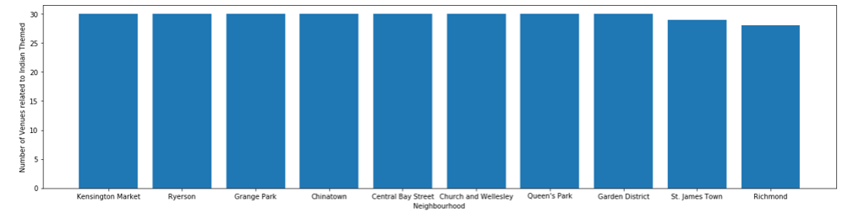

We find that the following Neighbourhoods have 30 such venues in the span 2KM radius within reach.

* Kensington Market
* Ryerson
* Grange Park
* Chinatown
* Central Bay Street
* Church and Wellesley
* Queen’s Park
* Garden District

Let’s have a look at this neighbourhoods on a map and confirm our segregation. Later on, we’ll distinguish these data’s in terms of the number of Indian cuisine restaurants and Indian markets.

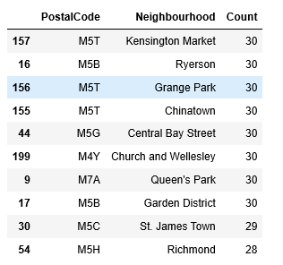

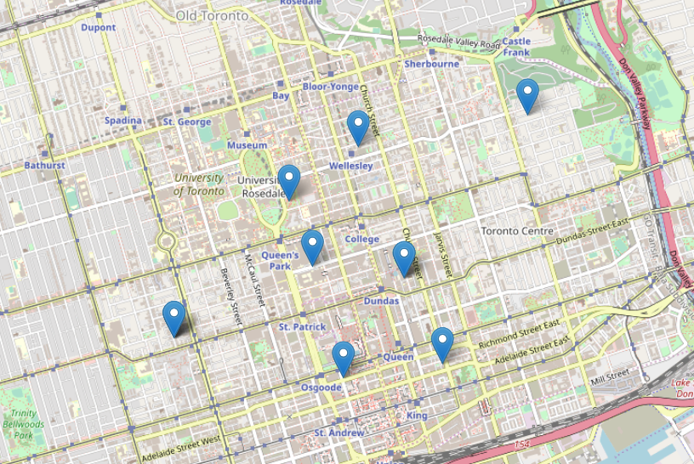

These are the 8 neighbourhoods that will provide the maximum Indian ethnicity to Indian travellers.

Now coming to the part of the analysis where we go through each neighbourhood and check which all neighbourhood has the greatest number of Indian Cuisine Restaurants.

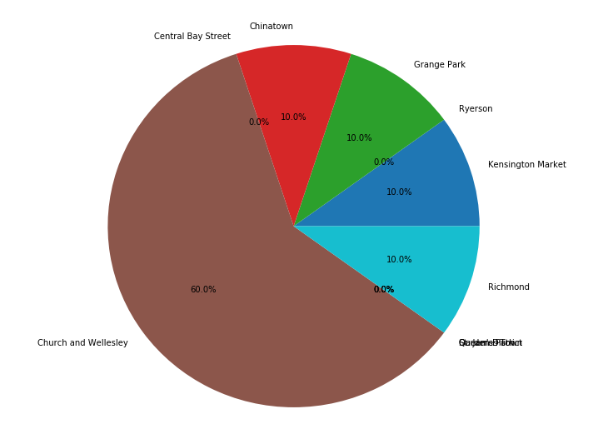

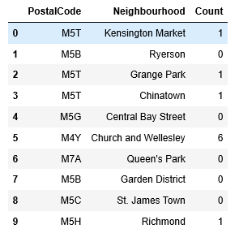

Out of the 10 neighbourhood we find that “Church and Wellesley” neighbourhood has the highest number of Indian Cuisine Restaurants.

In this case for an Indian traveller who is not well versed in cooking then Church and Wellesley will be the ideal neighbourhood for them to settle in, as the neighbourhood provides them with 6 different Indian restaurants.

Now analysing the Indian Grocery Stores,

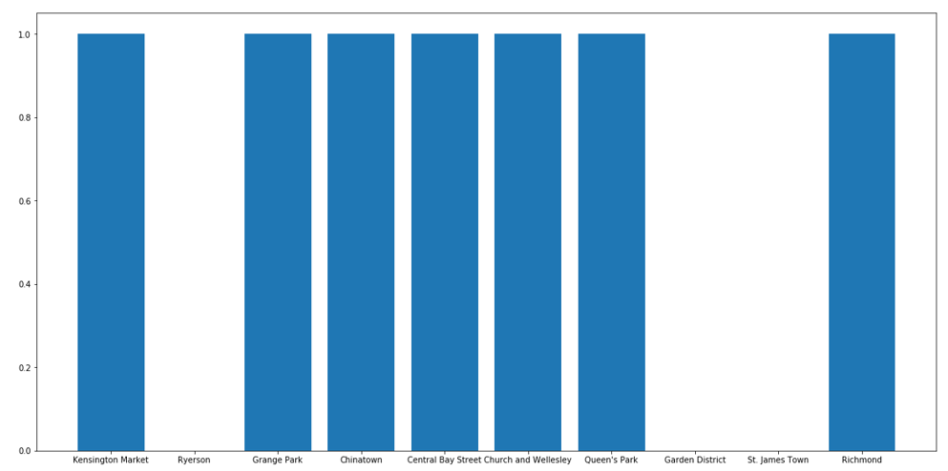

We see that Ryerson, Garden District and St. James Town doesn’t have an Indian grocery store.

When we check for Supermarkets in these neighbourhoods, the result is as follows in the graph:

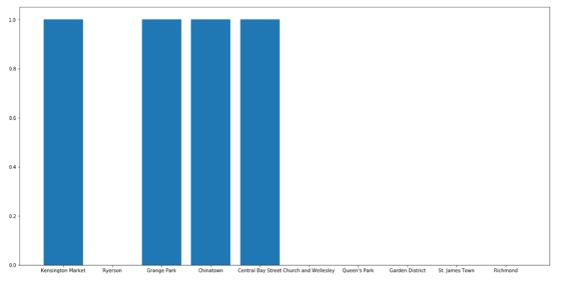

Only 4 Neighbourhoods has Supermarkets and the rest of the neighbourhood has only local stores.

For our final Analysis I’ll compare all these 10 neighbourhoods with an overall of how many markets are there in each of them irrespective of them being Indian.

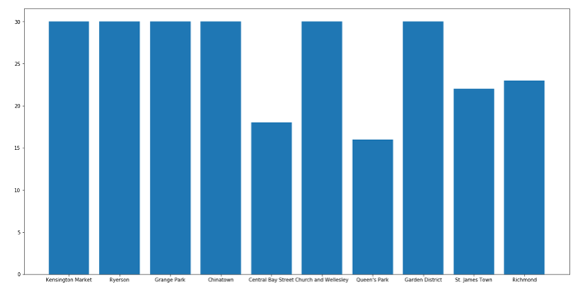

# Conclusion

At the end of the report we find that, the best neighbourhood for an Indian to settle into Toronto are: -

* **In terms of Restaurants -** Church and Wellesley
* **In terms of Market Density –** Kensington Market, George park and Chinatown
* **Overall –** Church and Wellesley

The following result is totally dependent on the data provided by Foursquare API and the results obtained can be varied when applied with a different source.